SNAC April 2021 Newsletter

From the Operations Committee

Announcements
Director, Daniel Pitti (dpitti@virginia.edu)

The Cooperative is pleased to welcome as a new member the Litchfield Historical Society.

SNACSchool
The NARA SNAC Liaisons Team, acting for the SNACSchool Team, hosted a special 1-day SNACSchool event on March 31st, to train 18 new editor members from the Arquivo Nacional do Brasil (National Archives of Brazil), which recently joined the cooperative.

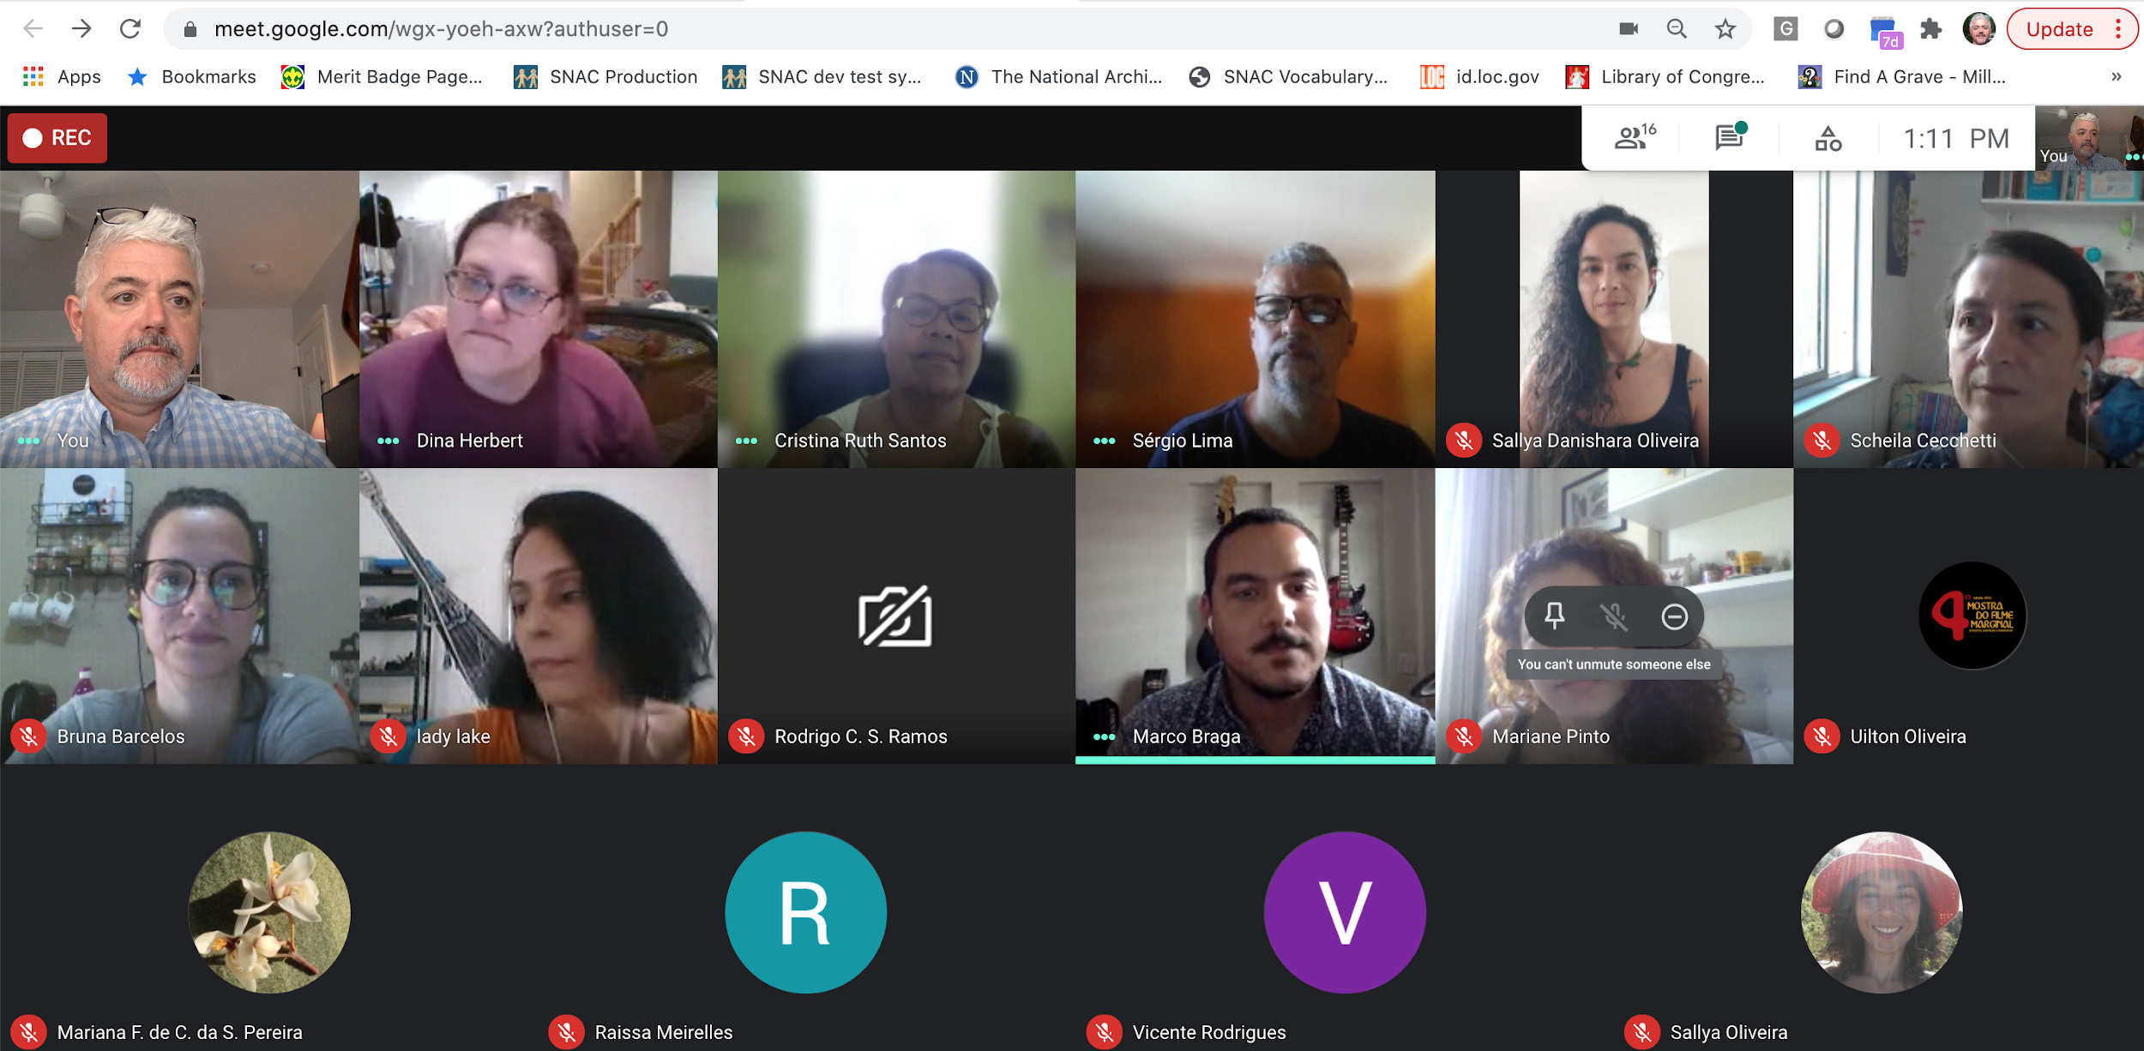
Photograph used with permission from Aquivo Nacional do Brasil staff, Mar. 31, 2021.

SNACSchool training calendar for the remainder of 2021:
- April - No training scheduled during development for SNACSchool 3.2
- May 12-13 - SNACSchool returns with version 3.2
- June 16-17
- July - No training scheduled
- August 4 - (1-day event during SAA conference week)
- September 22-3
- October 13-14
- November 17-18
- December 15-16

Members of the SNACSchool Team are collaborating with partners from the University of Maryland, the Harvard Peabody Museum, and an Indigenous Advisory Board to plan a SNAC Edit-a-thon for Native and Indigenous entities, hopefully set for late summer or early fall 2021. This collaborative Edit-a-thon project will be driven by input from Native and Indigenous communities at every stage of the process.

SNAC Stats
The following includes general statistical information about use of SNAC’s research portal.

As of reporting time (Tuesday, March 30, 2021), there were 3,723,976 identity constellations and 2,101,441 resource descriptions in SNAC. In the past month, SNAC had over 81,000 users and referred over 4,985 visitors to holding institutions’ sites.

SNAC-related Publications
We invite Cooperative members to share articles, blog posts, and any other published content about SNAC and SNAC-related topics or projects. Please send citations, with links, to Faith Charlton, Chair of the Communications Working Group at faithc@princeton.edu.

Member News
We invite Cooperative members to share news about SNAC-related projects or initiatives that they are undertaking, such as workflows and policies for creating or enhancing identity constellations, or if members want to highlight identity constellations. Please send a short (150-words max) blurb to Faith Charlton, Chair of the Communications Working Group at faithc@princeton.edu.

Working Group Updates

Communications:
Faith Charlton, Chair (faithc@princeton.edu)

Developer’s Update:
Joseph Glass, Lead Developer (jhg2v@virginia.edu)

The SNAC OpenRefine extension has an improved simple installation. The latest version can be downloaded here as a zip file. Complete installation instructions can be found on the OpenRefine website.

Technology Infrastructure:
Alex Duryee (alexanderduryee@nypl.org) and Iris Lee (ilee@amnh.org), Co-chairs

TIWG is reviewing the ArchivesSpace 3.0.0 Release Candidate and will send along any comments to LYRASIS before its final release. The WG is also reviewing the EAC 2.0 draft and preparing feedback on it. In addition, the WG is beginning to compile resources related to using SNAC’s API and OpenRefine extension.

Editorial Standards:
Susan Pyzynski, Chair (pyzynski@fas.harvard.edu)

NEW Preferencing Fuller Name Policy - https://portal.snaccooperative.org/node/523
March Minutes available: https://docs.google.com/document/d/1__tDSnTcLT5JqfScudAearCENb-S6HsiEF739JR8IRM/edit

Reference and Research:
Marisa Bourgoin, Chair (BourgoinM@si.edu)

___________________________________________________________________________
The SNAC Cooperative monthly newsletter provides news about SNAC activities and is sent to our Cooperative Members listserv, which is open to anyone interested in SNAC. Those interested in subscribing to the listserv can do so here: http://lists.village.virginia.edu/mailman/listinfo/snac-coopmembers.
Past issues of the newsletter are available on SNAC’s website.
To comment on or request more information about the SNAC newsletter please contact the Communications Working Group Chair, Faith Charlton, at faithc@princeton.edu or fill out the contact form at https://snaccooperative.org/contact.

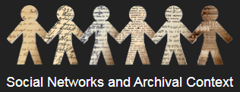
https://snaccooperative.org/
@SNACcooperative
YouTube

