SNAC November 2021 Newsletter

From the Operations Committee

Annual Meeting
Recordings of this year’s annual meeting are now available on SNAC’s YouTube channel and presentation slides are available on the SNAC website.

As a reminder for those who were able to attend, the Operations Committee would ask that you please fill out this brief survey to help us plan for next year’s meeting. We’ve extended the deadline for submission until November 5. Thanks!

Indigenous SNAC Editathon, October 11-12, 2021

The NARA SNAC Liaisons Team (hereafter the Team) is proud to have co-hosted the Indigenous SNAC Editathon on October 11 and 12, 2021, with our growing family of SNAC editors and collaborators. The Team wishes to thank Diana Marsh and Lydia Curliss of the University of Maryland’s iSchool, Katherine Meyers Satriano of the Peabody Museum of Archaeology and Ethnology, and Irene Gates of the New School, all of whom makeup the Editathon’s collaborative organizers. Special thanks also to the Editathon’s Indigenous Advisory Board comprised of Marge Bruchac (University of Pennsylvania), Stephen Curley (National Native American Boarding School Coalition), Taylor Gibson (Gāhsronih); Eric Hemenway (Little Traverse Bay Bands of Odawa Indians), Keahiahi Long (University of Hawaiʻi at Mānoa), and Melissa Stoner (University of California at Berkeley).

The event kicked off with an opening event (virtual), where Taylor Gibson provided a Cayuga welcome. Marge Bruchac also offered thanks and welcome. Special thanks also to Elizabeth Solomon (Massachusett Tribe at Ponkapoag) for her kind welcome and words lauding the importance of the Editathon event. Thanks to the advisors, the event opened with “welcome” in a number of the Indigenous languages representing the entities and participants' communities:

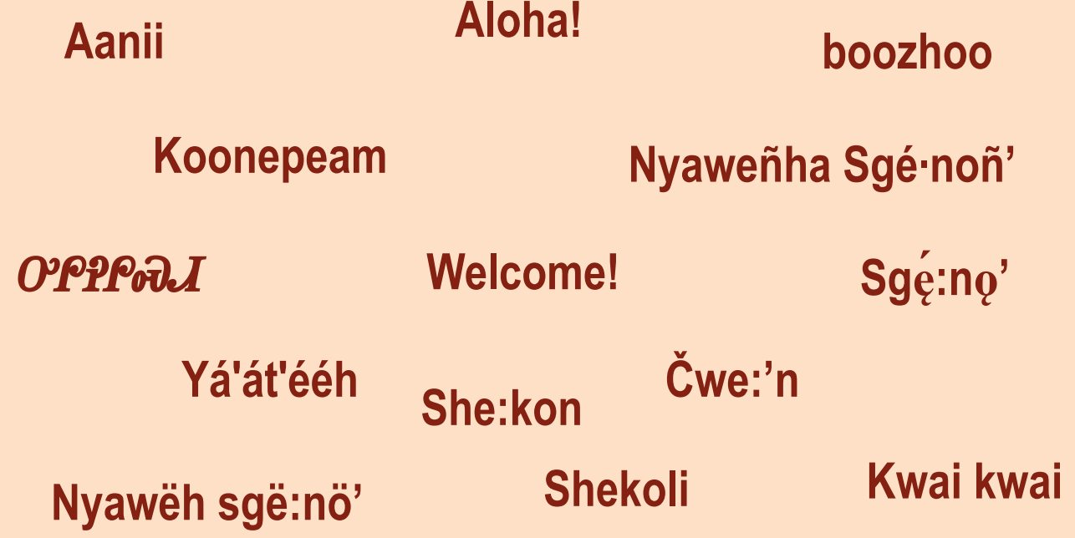

At the height of the editathon, there were as many as 90 new editors, 20 of whom identify as Indigenous, working collaboratively to create and edit/enhance 309 SNAC records describing Indigenous persons and organizations. Editors also edited 248 SNAC Resource Descriptions. The description style guide developed for the event continues in its editing phase, and the organizers plan to make it public in Summer 2022.

A sample of Editathon results can be seen in the SNAC record for Dennis James Banks.

SNACSchool Training
SNACSchool training calendar for the remainder of 2021:
- November 17-18
- December 15-16

Announcing SNACSchool dates for 2022!
- February 23-24, 2022
- March 23-24, 2022
- April 27-28, 2022
- May 25-26, 2022
- June 22-23, 2022
- August 24, 2022 (one-day event at SAA at Simmons University; details to follow)

Classes are limited to 25 students. Please email Dina Herbert to reserve your spot.

SNAC Stats
The following includes general statistical information about use of SNAC’s research portal.

As of reporting time (Tuesday, October 26, 2021), there were 3,710,830 identity constellations and ​​2,104,218 resource descriptions in SNAC. In the past month, SNAC had over 111,000 users and referred over 4,180 visitors to holding institutions’ sites.

SNAC-related Publications
We invite Cooperative members to share articles, blog posts, and any other content they’ve published about SNAC and SNAC-related topics or projects. For inclusion in the newsletter, please send citations, with links, to Faith Charlton, chair of the Communications Working Group at faithc@princeton.edu. If you’d like to highlight content on SNAC’s Twitter, please use this form to submit your request.

Member News
We invite Cooperative members to share news about SNAC-related projects or initiatives they are undertaking, such as workflows and policies for creating or enhancing identity constellations, particularly those of individuals or groups from underrepresented communities, or if members want to highlight identity constellations. For inclusion in the newsletter, please send a short (150-words max) blurb to Faith Charlton, chair of the Communications Working Group at faithc@princeton.edu. If you’d like to highlight news on SNAC’s Twitter, please use this form to submit your request.

Working Group Updates

Communications:
Faith Charlton, Chair (faithc@princeton.edu)

Have SNAC-related information that you’d like to post to SNAC’s Twitter account (@SNACcooperative)? The Communications Working Group invites Cooperative members to share news about SNAC-related projects, initiatives, or events, or to highlight identity constellations, particularly those of individuals or groups from underrepresented communities, which we will post on SNAC Twitter. Please use this form to request a scheduled tweet!

Technology Infrastructure:
Alex Duryee, Chair (alexanderduryee@nypl.org)

The TIWG is exploring new projects for the next year. Potential projects include enhancing SNAC’s place records, cleaning up existing place names, and developing use cases for the SNAC OpenRefine plugin.

Reference and Research:
Marisa Bourgoin, Chair (BourgoinM@si.edu)
The R&RWG has begun a rotating schedule of responding to SNAC tickets. We will meet next on November 9 to discuss FAQs and help content on the SNAC site.

___________________________________________________________________________
The SNAC Cooperative monthly newsletter provides news about SNAC activities and is sent to our Cooperative Members listserv, which is open to anyone interested in SNAC. For those interested in subscribing to the listserv, please email snaccooperative@gmail.com. Past issues of the newsletter are available on SNAC’s website. To comment on or request more information about the SNAC newsletter please contact the Communications Working Group Chair, Faith Charlton, at faithc@princeton.edu or fill out the contact form at https://snaccooperative.org/contact.

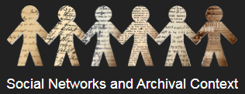
https://snaccooperative.org/
@SNACcooperative
YouTube

